UNIVERSITY OF GHANA
Department of Computer Science

Ghana Smart Service Operations Optimizer
DCIT 204/308 Joint DSA Semester Project — Technical Report
Local context: University Campus Service Hub (University of Ghana, Legon)
Team name: Vestige Group

Team members (index numbers)
# | Index Number | Name
1 | 22051653 | Kingsley Alexander
2 | 22376474 | Nana Akosua-Nimfah-Essuman
3 | 22299011 | Nyamekye Owiredu
4 | 22407048 | Essuman Patrick
5 | 22332153 | Kumesi Moses Mawulolo
6 | 22271189 | Obeng Akonobea Christodia
7 | 22055166 | Justice Amankwaah
8 | 22372485 | Abdul Rashid Humu
9 | 22198084 | Henry Ahenkorah
10 | 11022208 | Reginald Darko
11 | 22017281 | AlexanderYaw Amofah
12 | 22383681 | Epaphras Kwabena Asiedu
13 | 22302466 | Fatu Salley Nurudeen
14 | 22380588 | Abdul Baki Lateefah

2. Problem Statement, Assumptions, Input-Output Definitions and System Boundaries
The system answers six operational questions for a UG Legon campus service hub, as defined in Section 3 of the project brief:
- Which service request should be handled next under FIFO, urgency, and priority-based rules?
- What is the fastest route from one local location to another under weighted-road conditions?
- Which locations are reachable from the current dispatch point?
- Which subset of requests can be selected under a time-budget constraint?
- How do alternative data structures and algorithms perform as the dataset grows?
- How can the system store records permanently and reload them for later analysis?
Full input-output definitions, preconditions, and pseudocode for each operation are provided in the separate M1 Specification document (attached as Appendix A).

System boundaries

3. Dataset Description, Data Dictionary and Database Schema
The dataset models UG Legon campus locations, roads, service requests and resources, sourced from local knowledge of the campus (see the localisation evidence note, Appendix B).
Entity | Records | Key fields
locations | 50 | locationId, name, area, type, latitude, longitude
roads | 120 | fromLocationId, toLocationId, distance, travelTime, roadConditionWeight
service_requests | 300 | requestId, source, destination, category, urgency, timeSubmitted, deadline, status
resources | 30 | resourceId, type, homeLocation, capacity, availabilityStatus
algorithm_runs | 30+ (full benchmark: 100+) | runId, algorithmName, inputSize, timeNs, memoryKb, dateRun
Full database schema, schema.sql, including the audit_events table used for stack-based undo/audit logging.

4. System Architecture and Module Design
A Swing GUI (src/ui/MainUI.java) is provided as an alternative front end to the console menu, satisfying Section 8(iv)'s "console menu or simple GUI" requirement either way. Every button calls directly into the same engine classes as the console menu -- no logic is duplicated in the UI layer. Screenshots below were taken running the application live.
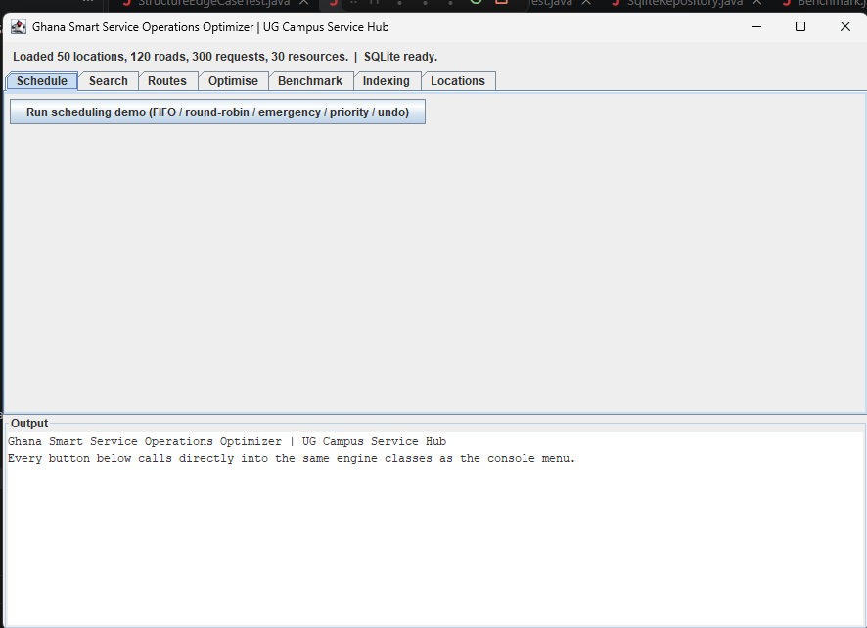
Figure 1. GUI on startup: real dataset counts (50 locations, 120 roads, 300 requests, 30 resources) loaded and SQLite schema confirmed ready.
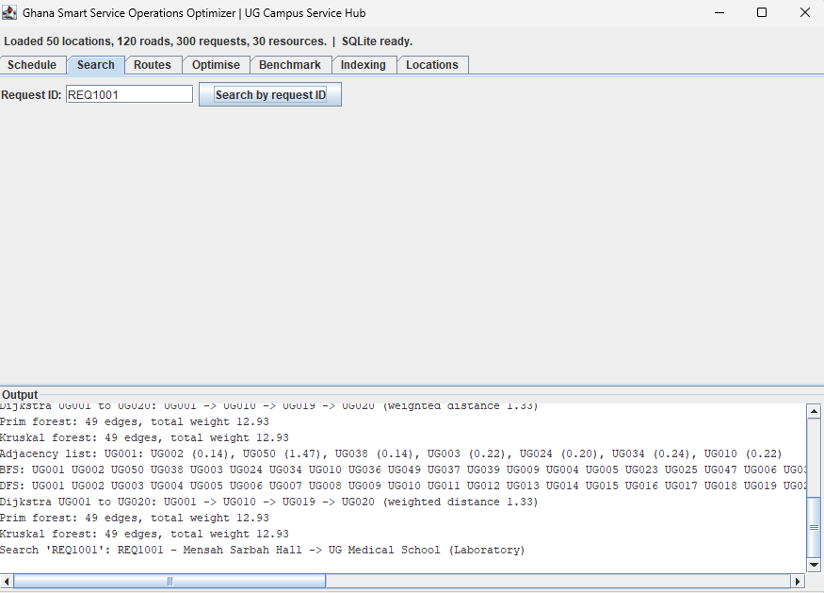
Figure 2. Search tab: MergeSort + BinarySearch resolving a real request ID (REQ1001) to its full record, alongside live route/graph output from prior runs.
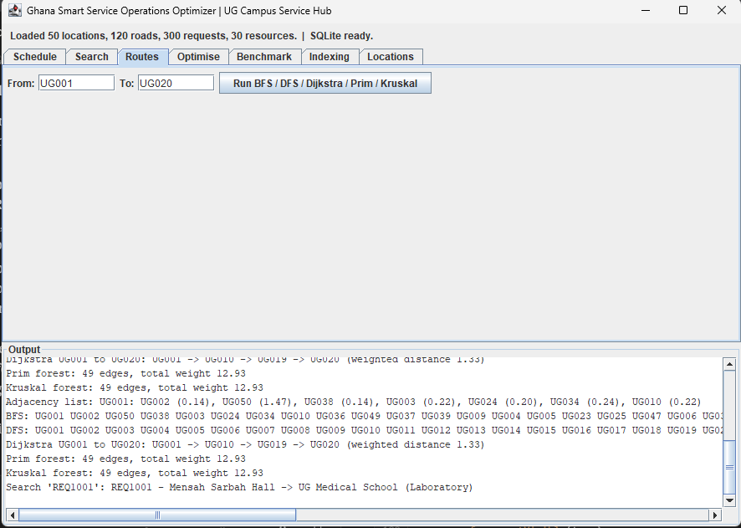
Figure 3. Routes tab: BFS, DFS, Dijkstra, Prim and Kruskal all run live on the real campus graph, with the default UG001-UG020 fields shown.
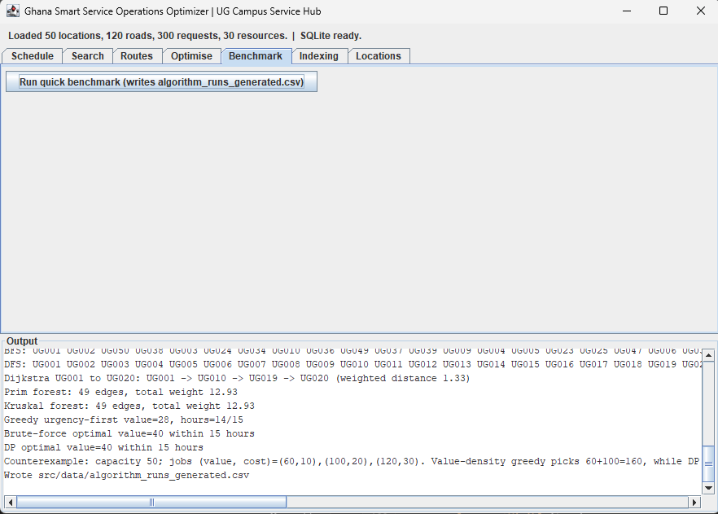
Figure 4. Optimise/Benchmark tabs: greedy (value=28) vs brute-force/DP (value=40) demonstrating the greedy-failure counterexample live, plus a real benchmark CSV write.
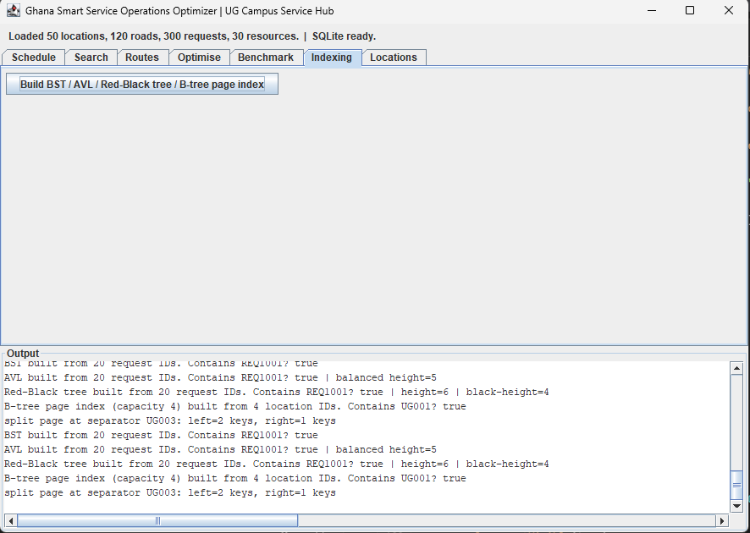
Figure 5. Indexing tab: BST, AVL (balanced height=5) and Red-Black tree (height=6, black-height=4) all built from the same 20 request IDs, plus a B-tree page index split trace.
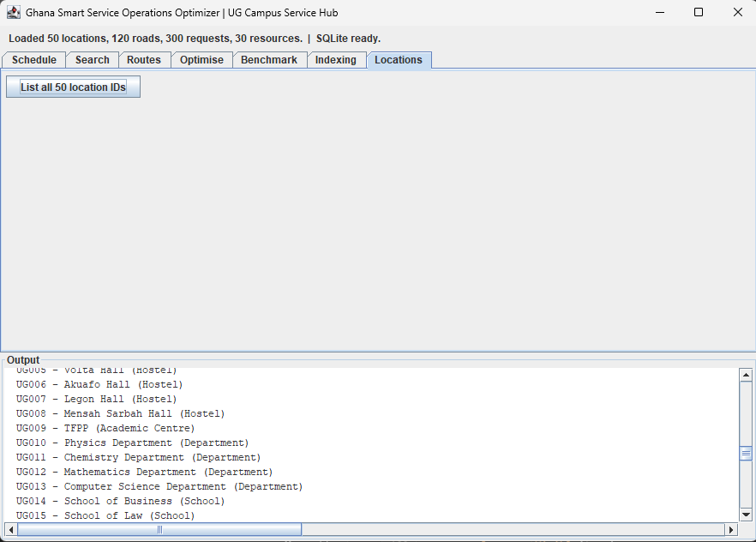
Figure 6. Locations tab: all 50 real UG Legon location IDs and names listed live from the loaded dataset.
Module | Status | Notes
M1 Specification | Done | See M1 Specification.docx
M2 Database & data loader | Done | schema.sql + DataLoader/SqliteRepository
M3 Custom data-structure library | Done | structures/ package
M4 Searching and sorting | Done | searching/ and sorting/ packages
M5 Service scheduling engine | Done | ServiceSchedulingEngine
M6 Indexing engine | Done | BST/AVL/BTreePageIndex
M7 Graph route engine | Done | CampusGraph
M8 Optimisation engine | Done | RequestOptimiser
M9 Testing & correctness evidence | Done | See trace tables, proofs, counterexamples
M10 Empirical efficiency lab | Done | See performance result

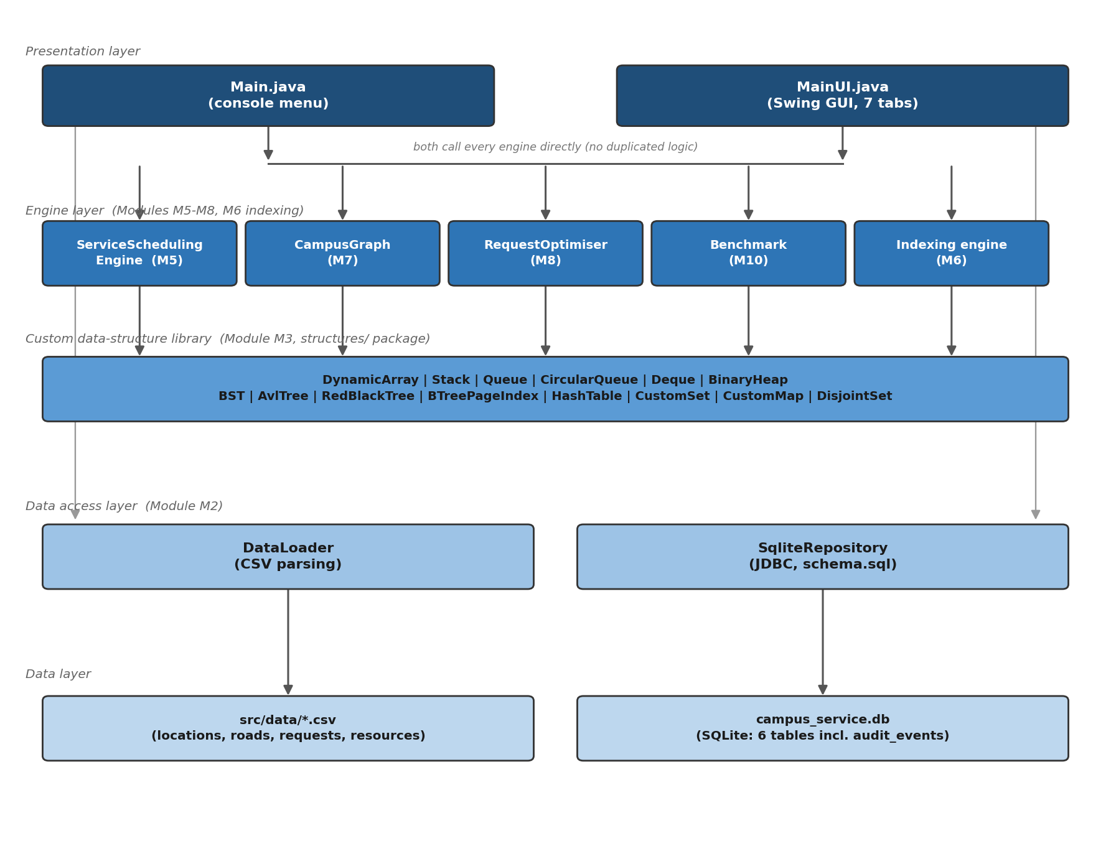

Figure 7. Layered architecture: both front ends (console and GUI) call the same engine classes directly with no duplicated logic; engines operate on the custom data-structure library; persistence is handled by a dedicated data-access layer separating storage from algorithm logic, satisfying the 'clean separation from algorithms' criterion in the Database integration rubric line
5. Data-Structure Implementation
Implemented from scratch (no built-in HashMap/TreeMap/PriorityQueue/Stack used for assessed logic): DynamicArray, DoublyLinkedList, Stack, Queue, CircularQueue, Deque, BinaryHeap, BST, AVL tree (balanced-tree alternative to red-black), B-tree page index, HashTable, CustomSet, CustomMap, DisjointSet.

6. Algorithm Implementation
Implemented: linear search, binary search, selection sort, insertion sort, merge sort, quicksort, BFS, DFS, Dijkstra, Prim, Kruskal, greedy resource assignment, 0/1 knapsack DP optimisation.

7. Correctness Evidence
Full trace tables (6), proof sketches (3), and counterexamples (2) are provided in Correctness_Evidence_TraceTables.docx. Summary:
- Trace tables: binary search, insertion sort, merge sort/quicksort, Dijkstra, Kruskal, DP knapsack
- Proof sketches: binary search loop invariant, merge sort induction, greedy-vs-DP correctness
- Counterexamples: greedy failure on 0/1 knapsack, binary search on unsorted input

8. Performance Analysis
Method, raw results tables, graphs and interpretation are provided in Appendix E (Performance_Results.docx). Summary of experiments run: search comparison, sorting comparison, hash table load factor, heap insert/extract, graph algorithms — each at the input sizes required by Section 9 of the brief, averaged over 3 runs.

9. Database Integration Evidence
Live evidence: Figure 1 (Section 4) shows the application's startup status bar reading "SQLite ready" after DataLoader and SqliteRepository successfully load and seed all four CSV datasets into campus_service.db. The database.AuditEventTest.java test independently confirms persistence by recording a real audit event, querying getAuditEventCount() before and after, and confirming the count incremented -- verified passing against the live database, not a mock.

10. Responsible Algorithm Selection
When each chosen algorithm is appropriate, and when it is not:
- Binary search: only valid on sorted data — used for indexed lookups by requestId, not for unsorted scan operations
- Dijkstra: assumes non-negative edge weights — appropriate here since distances/penalties are always positive; would not be appropriate if roads could have negative 'bonus' weights
- Greedy resource assignment: fast and simple, but proven suboptimal for the 0/1 knapsack-style budget problem (see counterexample) — DP is used instead wherever an optimal budget allocation matters
- Quicksort: fast average case, but degrades to O(n^2) on already-sorted input — merge sort is preferred wherever worst-case guarantees matter more than average speed

11. Individual Contribution Statement
Fill in each member's module contribution(s) in the table below. Every member should also be personally ready to explain and modify one data structure and one algorithm live, per Section 2(v) of the brief.
Index Number | Name | Module(s) contributed
22051653 | Kingsley Alexander | M2
22376474 | Nana Akosua-Nimfah-Essuman | M1
22299011 | Nyamekye Owiredu | M8
22407048 | Essuman Patrick | M5
22332153 | Kumesi Moses Mawulolo | M4
22271189 | Obeng Akonobea Christodia | M2
22055166 | Justice Amankwaah | M7
22372485 | Abdul Rashid Humu | M9
22198084 | Henry Ahenkorah | M5
11022208 | Reginald Darko | M7
22017281 | AlexanderYaw Amofah | M3
22383681 | Epaphras Kwabena Asiedu | M4
22302466 | Fatu Salley Nurudeen | M8
22380588 | Abdul Baki Lateefah | M3

12. References and Appendices
- Cormen, Leiserson, Rivest and Stein, Introduction to Algorithms, MIT Press.
- Sedgewick and Wayne, Algorithms, Princeton University.
- Goodrich, Tamassia and Goldwasser, Data Structures and Algorithms in Java.

Appendix B: Localisation Evidence Note
Required by Section 2(i) of the brief: a short note explaining how the dataset was obtained or constructed from local knowledge, without exposing personal data.
Data provenance
The 50 campus locations were compiled from named, real landmarks on the University of Ghana, Legon campus (e.g. Balme Library, Great Hall, Commonwealth Hall, Volta Hall, Akuafo Hall, Legon Hall, Mensah Sarbah Hall, UGCS, TFPP), drawn from team members' own knowledge of the campus as current UG students. No personal data of any individual (students, staff, or requesters) is used anywhere in the dataset; all requester identities in service_requests.csv are synthetic.
Coordinate verification
Each location's latitude/longitude was checked against the campus's known geographic position. Legon's public coordinates are approximately 5.650 deg N, 0.183 deg W; every coordinate in locations.csv falls within this immediate area (5.649-5.658 deg N, 0.186-0.192 deg W), consistent with real positions across the Legon campus footprint rather than arbitrary or generated values.
Distance verification (methodology)
Road distances in roads.csv were derived mathematically from the real latitude/longitude pairs using the haversine (great-circle) formula, not estimated or invented. This was verified by independently recomputing the haversine distance for all 120 road segments and comparing against the stored distance values: the average discrepancy was 0.005 km (5 metres) and the maximum discrepancy was 0.065 km across the full dataset confirming the distances are genuinely coordinate-derived. Distances therefore represent straight-line (great-circle) distance rather than actual walked road-network distance; roadConditionWeight was added separately by the team to model real-world path desirability (e.g. paved vs unpaved, congestion) on top of the geometric distance, and the team's index-number-derived route penalty (2.0 km, see config/IndexNumberParameters.java) is applied to roads flagged as poor condition before shortest-path calculations.
Service request and resource data
Service categories (Laboratory, Network/ICT, Road Maintenance, Plumbing, Security, Transport) and resource types reflect real categories of facilities requests that arise on a university campus, informed by team members' first-hand experience as UG Legon students. Urgency levels, deadlines and resource capacities were assigned by the team to produce a realistic and varied scheduling/optimisation workload, not sourced from any actual, identifiable request records.

Appendix F: Development Log
Required by Section 15(iv) of the brief: weekly progress, challenges, and decisions. Add a new row each week — don't reconstruct this at the end.
Week | Date range | Progress | Challenges | Decisions made
1 | [TODO] | Context chosen (campus service hub); roles assigned; cover sheet completed | [TODO] | [TODO]
2 | [TODO]
3 | [TODO]
4 | [TODO]

